Workshop on
Fundamentals of Biomedical Research Methods
December 20 to 22, 2017

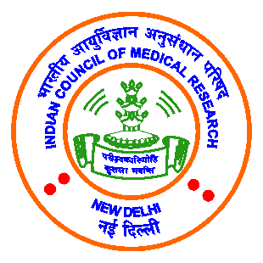

Registration Form

Name ……………………………………………………………………
Age ……………………………………………………………………
Gender (Male / Female) ……………………………………………………………………
Current Education ……………………………………………………………………
Organization ……………………………………………………………………
Education Background ……………………………………………………………………
Address ……………………………………………………………………
……………………………………………………………………
……………………………………………………………………
Contact (Mobile) No. ……………………………………………………………………
Email ……………………………………………………………………
Expectations from the Workshop:

Details of Registration fee: Rs. 1500/=(In favour of Indian Public Health Association, payable at Kolkata)
DD No: Bank: Issue Date:
Amount: Rupees in words:

NEFT may be done:-
Name of Account : Indian Public Health Association
Name of Bank : IDBI Bank Limited
Branch Address : Girish Park Branch, Meridian Plaza
209, Chittaranjan Avenue, Kolkata- 700006
Account No. : 0196104000053084
IFSC Code : IBKL0000196
MICR Code : 700259010

Signature of Candidate

