62nd Annual National Conference of
Indian Public Health Association
9-11 February, 2018
Scientific Convention Centre, KG Medical University, Lucknow, UP
A Brief Report
The 62nd Annual National Conference of Indian Public Health Association was held from 9th February to 11th February 2018 at Scientific Convention Centre, KG Medical University, Lucknow. Over 800 delegates from all over the country participated in the conference. Two Pre-Conference Training Courses on Good Research Grant Proposal Writing and Design and Conduct of Large Scale Surveys were also held on 8th Februaryy, 2018 in which nearly 100 postgraduate and young faculty members participated. The Conference was inaugurated by Hon’ble Union Mnister of State for Health & Family Welfare Smt. Anupriya Patel inaugurated the conference.

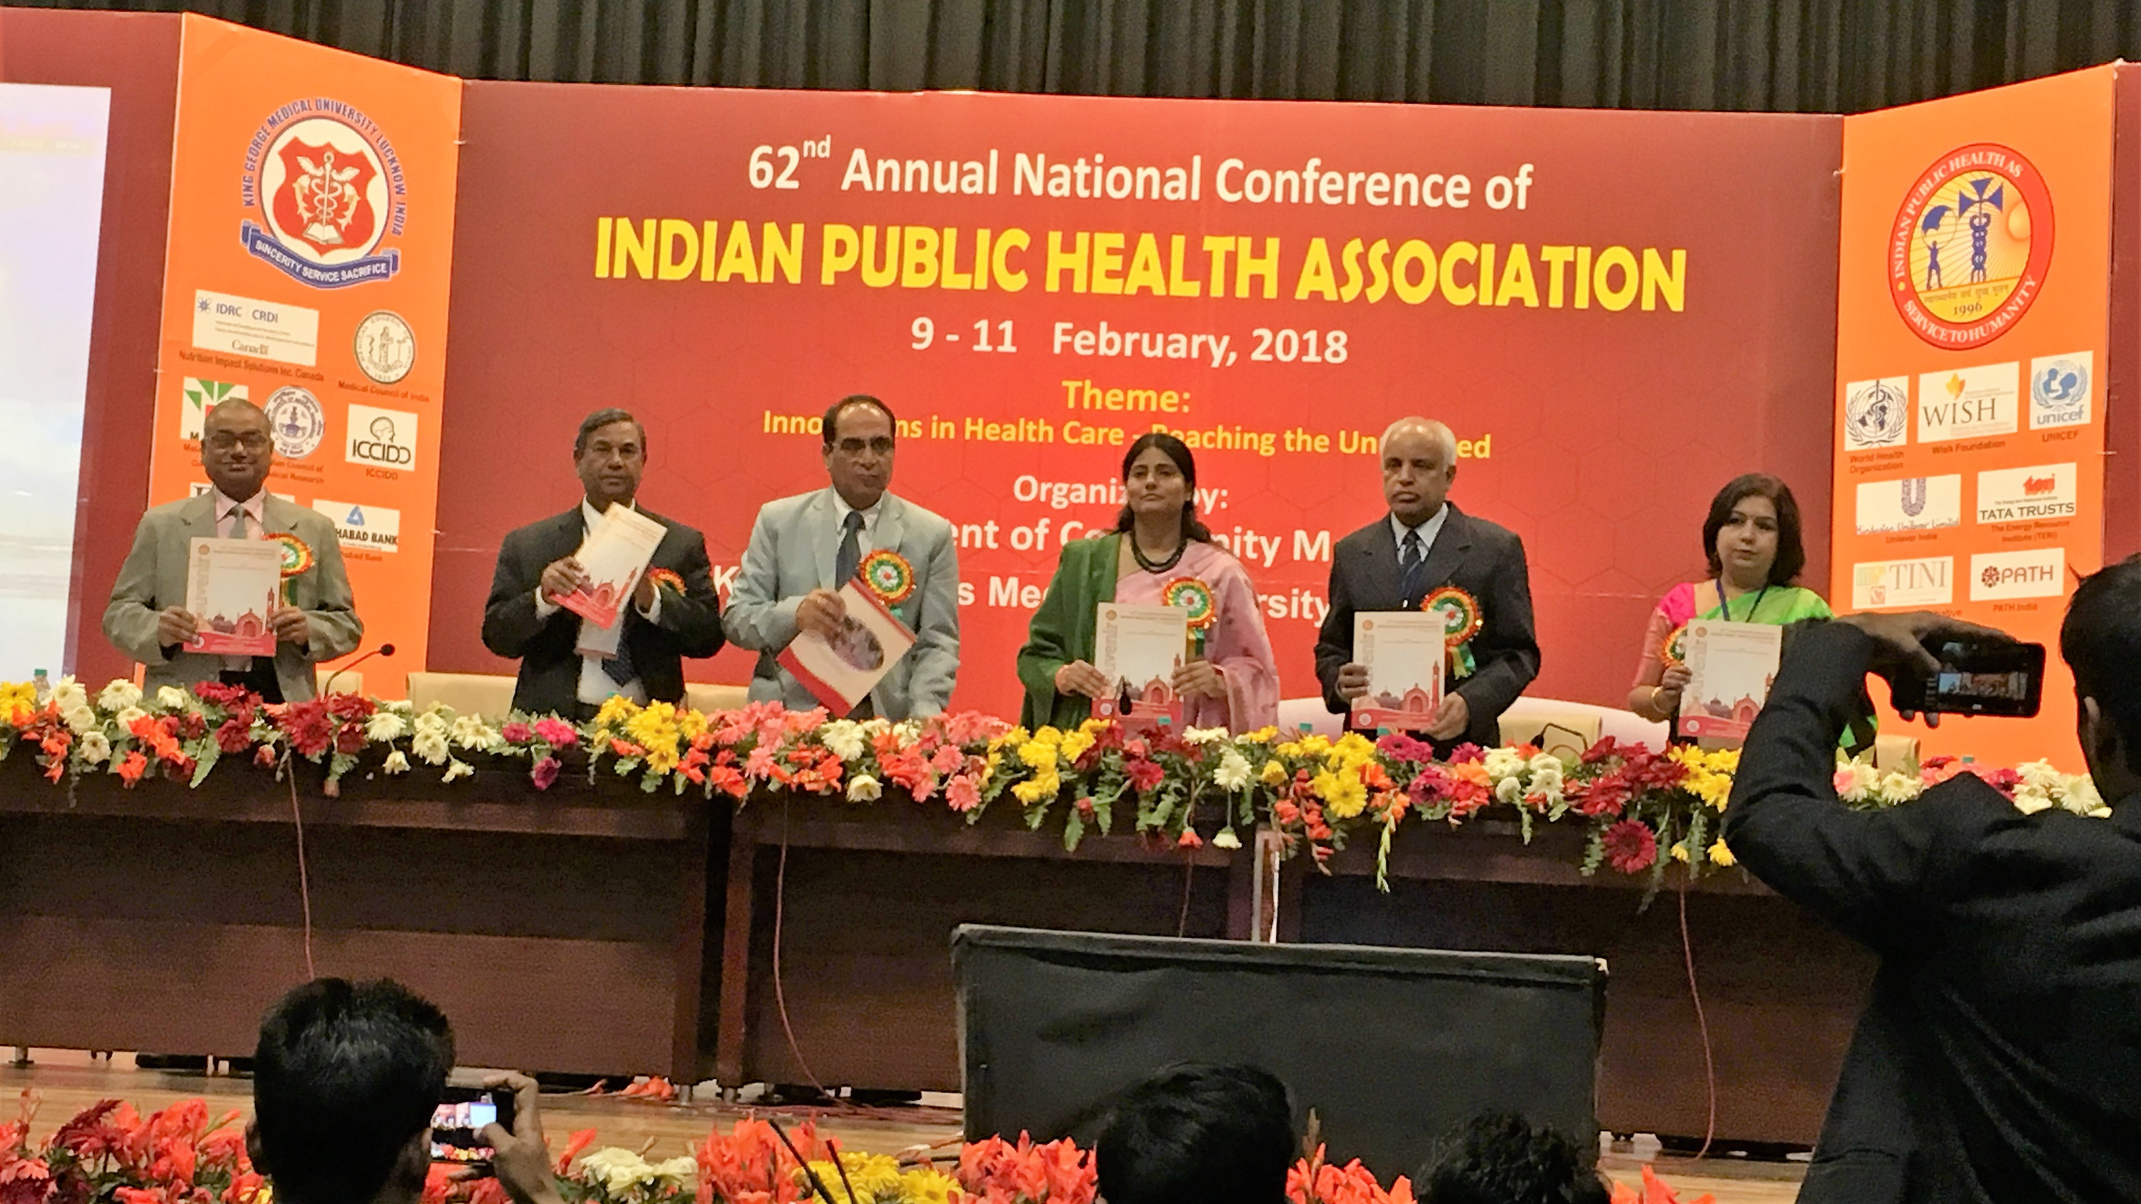

There were three Orations; the Dr. BC Dasgupta Memorial Oration was delivered by Dr. Anand Krishnan, Professor, AIIMS, New Delhi while Dr. JE Park Memorial Oration was delivered by Dr. A Kiran Kumar, Former Director of Public Health, Grand Cayman, West Indies and Dr. Suneela Garg, Professor & Head, Community Medicine, Maulana Azad Medical Collegem, New Delhi, delivered Dr KN Rao Memorial Oration.

There were Nine Plenary Sessions on following topics:

- Plenary session-I Gender Equity and Quality – Next Frontiers for Newborn
Survival

- Plenary Session-II Blended Finance and Development Impact Bond in Health
- Plenary Session-IV Climate science, pathways to health effects, and role of
global and local level stakeholders in decision making

- Plenary Session-V Basic Occupational Health Services
- Plenary Session-VI Pre term kit – A bundled approach to reducing premature
Morbidity and mortality in India

- Plenary Session-VII Lymphatic Filariasis and Other Neglected Tropical Diseases
- Plenary Session-VIII AES/Japanese Encephalistis
- Plenary Session-IX Role of Double Fortified Salt in reducing IDD and Anaemia -
Sharing experiences from Uttar Pradesh

- Plenary Session-IX Role of Palm Oil in Dietary Improvement

There were two Award sessions for best paper viz.

- Dr. PC Sen Best Paper Award on “Rural Health Practice” and
- Dr. SD Gaur Best Paper Award on “Environmental Health Practice”

A total of 25 Scientific Sessions (13 Oral and 12 Poster) on various Public Health issues were organized covering more than 370 scientific papers.

